* **CURVES**

* **LEVELS**

* **BLACK&WHITE**

* **HUE/SATURATION**

* **BRIGHTNESS&CONTRAST**

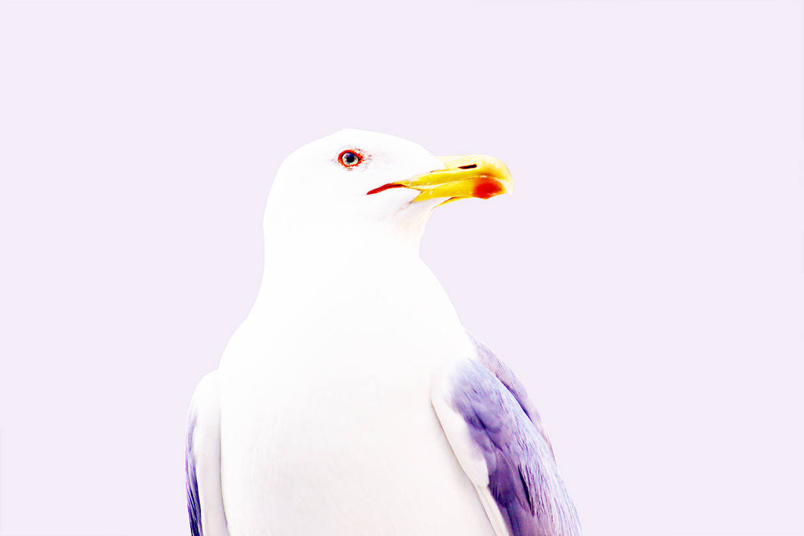

* **VIBRANCE**

